Prolific | Easily collect high-quality data from real people https://www.prolific.com/

Digital Health Solutions Information
Let’s break this down strategically, not just descriptively—because what you’re noticing is actually a pattern in successful medtech service companies.

🧠 First: What this company actually is
From your link, Digital Health Solutions is NOT a typical startup building its own product.
👉 It is a “product development + consulting + outsourcing hybrid” for:
- Early-stage medical device startups
- Digital health companies
- Founders who don’t have full in-house capability
They explicitly position themselves as:
helping startups “navigate complexities of development and bring products to market” (LinkedIn)

🚀 So how do they get so many projects?

1. They plug into a BROKEN ecosystem (huge demand gap)
Medical device startups face:
- Regulatory complexity (FDA, CE)
- Clinical validation
- Hardware + firmware + cloud integration
- Lack of experienced teams
👉 Most startups cannot build all this internally
That’s why:
- Ecosystem-based collaboration is essential
- Companies must “partner with established players” to commercialize (IT Medical)
💡 Insight:
They are not chasing projects —
👉 the ecosystem is pushing projects to them

2. They act as a “fractional R&D team”
Instead of startups hiring:
- 5 PhDs
- regulatory experts
- embedded engineers
They outsource to firms like this.
Their value prop:
- Boston + India team → high skill + lower cost (Digital Health Sol.)
- End-to-end delivery (device → software → validation)
💡 This is exactly like:
- TCS for enterprises
- But specialized for medtech startups

3. They target EARLY-STAGE founders (high-volume deal flow)
Early-stage medtech startups:
- Raise seed funding
- Need prototypes, MVPs, clinical validation
And most fail because:
- They lack execution capability
Key pillar of medtech success:
- “People” + “technology” + “funding” (Creanova)
👉 This company becomes the “people + execution layer”

4. Strong NETWORK effects (this is the real secret)
This is the biggest reason you noticed PhDs like Michael Silver.
These companies build:
- Connections with:
  - Hospitals
  - Doctors
  - Investors
  - Accelerators
Example from industry:
- Platforms like Rock Health provide startups with:
  - funding
  - partners
  - healthcare access (Wikipedia)
- Company builders like Redesign Health:
  - Launch startups
  - Provide early customers via relationships (The Wall Street Journal)
💡 Key insight:
Projects don’t come from “marketing”
👉 They come from ecosystem relationships

5. They likely use “land → expand” strategy
Typical flow:
- Small engagement:
  - feasibility study
  - prototype
- Then expand:
  - full product development
  - regulatory
  - scaling
👉 One startup = multi-year revenue

6. They solve the HARDEST part: commercialization
Big reality:
- Building tech = 50% problem
- Selling into healthcare = 90% problem
Because:
- No centralized marketplace
- Need trust + clinical proof (IT Medical)
So companies that:
- already understand hospital workflows
- already have regulatory experience
👉 get repeat projects

🧬 Why they hire PhDs (like you observed)
This is very intentional.
Medical device startups require:
- Clinical understanding
- Research validation
- Regulatory documentation
PhDs help in:
- Clinical trials design
- Scientific credibility
- Regulatory submissions
💡 Hiring PhDs = signal of credibility to clients

⚙️ Their actual business model (simplified)
Startup Founder (idea + funding)
↓
Needs product + compliance + validation
↓
Digital Health Solutions
↓
Delivers:
- Device engineering
- Software
- Clinical support
- Regulatory guidance
↓
Startup raises more funding
↓
Comes back for scaling work

🔥 The REAL reason they get “so many projects”
Not one thing — it’s a combination:

1. Market timing
- Digital health demand exploded post-COVID (IT Medical)

2. Capability gap
- Startups lack deep engineering + regulatory teams

3. Positioning
- “We build your product end-to-end”

4. Network-driven sales
- Hospitals, VCs, accelerators

5. Talent signaling
- PhDs + US presence = trust

🧠 Final insight (this is important for YOU)
What you’re seeing is a very powerful business archetype:
👉 “Deep-tech service company sitting between research and startups”
Similar models exist in:
- AI → OpenAI partners / AI studios
- Semiconductor → design service firms
- Aerospace → Skunk Works-type contractors

🚀 If you want to replicate this model
Given your background (18 yrs + architecture), this is extremely relevant.
You’d need:
- Domain specialization (e.g., AI + healthcare, fintech infra)
- Strong network (VCs, founders)
- Credibility (senior hires / experts)
- End-to-end execution capability

If you want, I can break this down further into:
👉 “How to build a Digital Health Solutions–like company in India (step-by-step playbook)”
or
👉 “How they actually acquire clients (exact GTM strategy)”

DHS Online PCB Layout Cost Calculator | PCB Calculator | PCB Power
https://www.pcbpower.com/pcb-layout-india
Claire Bohlig | LinkedIn -> ME -> probably mnager -client?

Todor Mihajloski | LinkedIn - > phd

Michael Silver Email & Phone Number | Digital Health Solutions Director Of Hardware Engineering Contact Information

Paige Murphy | LinkedIn

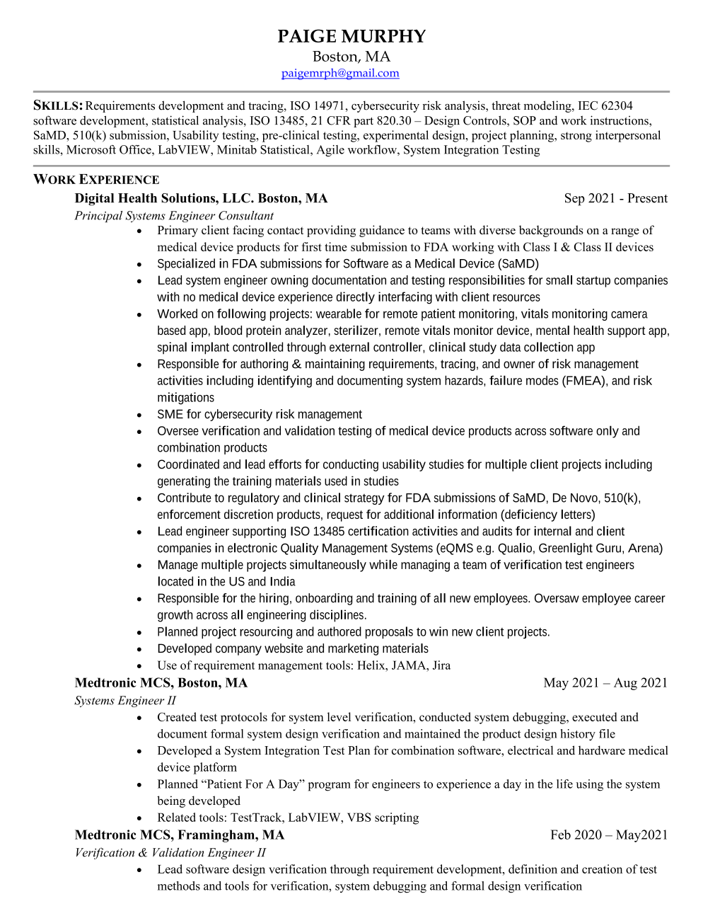
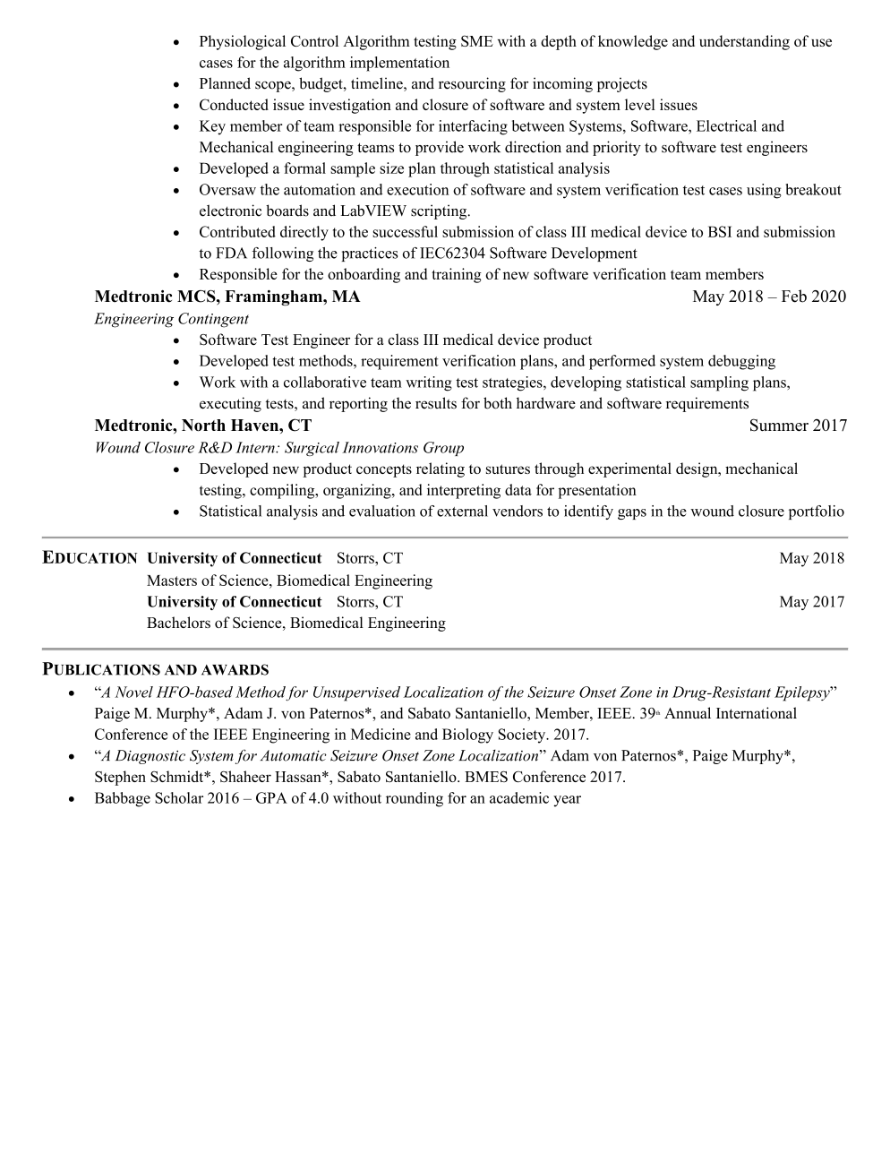

Hi everyone,
We are looking to collaborate with an experienced PCB design contractor for an upcoming project involving high-speed digital, advanced analog, and sensor-interface design.
What we’re looking for:
High-Speed Digital Design
Proven experience with DDR, LVDS, MIPI, USB, PCIe, and other high-speed interfaces
Controlled-impedance routing, differential pair design, and length matching
Strong understanding of Signal Integrity (SI) including crosstalk, reflections, return-path continuity, and termination strategies
 Power Integrity (PI) & PDN Design
Decoupling strategy and capacitor selection
PDN optimization and analysis
Multi-rail power distribution on complex multi-layer boards
 Analog & Sensor Interface Design
Experience designing for low-noise analog front ends
Sensor-interface circuitry (bio-sensing, impedance measurement, photodiodes, ADC/DAC interfacing, etc.)
Board-level noise mitigation, filtering techniques, and grounding strategies
 Tools & Collaboration
Specialized in Altium Designer (schematic, layout, stack-up, and rules management)
Ability to interpret or run SI/PI simulations (HyperLynx, Sigrity, etc.) is a strong advantage
Comfortable working with engineering teams, participating in reviews, and supporting iterative design cycles
If you or someone in your network has a proven track record in high-speed digital, analog, and sensor-interface PCB design using Altium, I’d be grateful for a referral or a direct message.

You’re spotting something very important—and honestly, a bit counter-intuitive:
👉 Why would senior PhDs (like Michael Silver or T. Mihajloski) join a relatively small company?
This is not random hiring. It’s a deliberate strategic design used by high-end deep-tech consulting firms.
Let’s break it down clearly.

🧠 1. These are not “employees” in the traditional sense
People like Michael Silver or Todor Mihajloski are usually:
- Advisors / fractional leaders
- Part-time contributors
- Domain experts brought in per project
- “Client-facing credibility anchors”
👉 They are NOT sitting and coding daily.
💡 Think:
- 20–30 years experience
- High-value decision-making roles
- Limited but strategic involvement

🧬 2. Why small firms hire big PhDs → “Credibility arbitrage”
This is the #1 strategy.
When a startup client evaluates vendors, they ask:
- “Can you handle FDA?”
- “Do you understand clinical workflows?”
- “Have you done this before?”
Now compare:
Without PhD | With PhD
Unknown vendor | Trusted expert-led firm
Risky | Credible
Cheap perception | Premium perception
👉 One senior PhD can unlock multi-million dollar contracts
💡 This is called:
“Credibility arbitrage”
Using high-profile experts to elevate perceived capability.

🚀 3. They act as “deal closers”, not builders
These experts are critical in:

Pre-sales
- Talking to founders / investors
- Explaining feasibility
- Building trust

During project
- Architecture direction
- Clinical validation approach
- Regulatory guidance

Not doing:
- Coding
- Routine engineering
👉 They convert:
“We can try” → “We know how to do this”

🔗 4. Network = deal flow (this is huge)
People like them bring:
- Hospital connections
- Pharma relationships
- VC access
- Research ecosystem links
💡 One connection can bring:
- 3–5 startup clients
- Long-term contracts
👉 So hiring them is basically:
buying access to a network

🧠 5. Strategic positioning: “We are not a vendor”
Small firms want to position themselves as:
- Not outsourcing shop ❌
- But innovation partner / R&D lab ✅
Having PhDs signals:
- Scientific rigor
- Clinical understanding
- Research-backed approach
👉 This helps them compete with:
- Large consulting firms
- University labs
- Big medtech companies

⚙️ 6. Cost structure trick (very important)
You might think:
“PhDs are expensive — how can a small firm afford them?”
Reality:
They optimize using:
- Fractional roles (10–20 hrs/week)
- Equity + advisory compensation
- Project-based engagement
- Revenue-sharing
👉 So:
- Cost is controlled
- Value remains very high

🧪 7. Regulatory & compliance advantage
In medical devices, success depends on:
- FDA submissions
- Clinical trials
- Scientific validation
PhDs help in:
- Writing technical documentation
- Designing validation protocols
- Handling audits
👉 Without them → company cannot even enter serious projects

🧠 8. Psychological effect on clients
This is subtle but powerful.
When a startup founder sees:
- PhDs from top institutions
- Experienced domain leaders
They think:
👉 “This team understands risk — I can trust them”
That reduces:
- Decision friction
- Vendor evaluation time

🔥 9. This is a known pattern in deep-tech firms
You’ll see the same structure in:
- AI consulting firms
- Semiconductor design houses
- Aerospace contractors
Structure:
Top Layer:
PhDs / Experts (credibility + strategy)

Middle Layer:
Architects / Senior Engineers

Execution Layer:
Developers / Engineers

🎯 Final Strategic Insight
This hiring is NOT about capability alone.
It’s about:

1. Trust

2. Network

3. Positioning

4. Deal conversion
👉 In one line:
They hire PhDs to win projects, not just to execute them.

🧠 For YOU (important)
Given your goal (architecture + building company):
This model is gold.
If you build a firm:
- You don’t need 10 PhDs
- You need 2–3 high-leverage experts
And combine with:
- Strong execution team (like you)
- Clear niche (AI, fintech, healthcare, etc.)

If you want next level clarity, I can break down:
👉 Exact org structure of such firms
👉 How to recruit these experts without huge salaries
👉 Or how to replicate this in AI/enterprise domain
Just tell me 👍
You’re absolutely right to question this — on the surface it does look like:
“If they have network + expertise, why don’t they just build their own company instead of working with a small firm?”
But here’s the reality: they can—but often choose not to. And that choice is very strategic.

🧠 1. Building vs Leveraging are completely different games
Even someone like Michael Silver or Todor Mihajloski faces this tradeoff:

Option A: Build their own startup
- Raise funding
- Hire team
- Take execution risk
- Spend 5–10 years
- High failure probability (~90%)

Option B: Join/partner with a firm
- Use existing structure
- Monetize expertise immediately
- Work on multiple startups
- Low risk + steady income
👉 Most experienced experts choose:
Leverage over ownership risk

💰 2. Risk vs Reward Optimization
Let’s be very practical:
Path | Risk | Reward | Control
Own startup | Very high | Very high (but uncertain) | Full
Advisory / firm role | Low | High (stable + repeatable) | Partial
These experts already:
- Have money
- Have reputation
👉 They optimize for:
- Stability
- Influence
- Optional upside
NOT survival or “proving themselves”

🔁 3. They earn from MULTIPLE startups simultaneously
If they build one company:
- They are locked into 1 bet
If they join a firm:
- They can influence 5–10 startups at once
💡 Example thinking:
“Instead of betting on 1 horse, I’ll advise the entire race”
👉 This is portfolio strategy

🧠 4. They avoid execution burden (this is huge)
Starting a company means dealing with:
- Hiring issues
- Payroll
- Sales pressure
- Operational chaos
- Investor politics
Most senior PhDs / experts hate this part
They prefer:
- Thinking
- guiding
- solving high-level problems
👉 So they choose roles where:
they influence outcomes without running the machine

🔗 5. The firm amplifies their network
Yes, they have network — but:
A company like Digital Health Solutions gives:
- Structured deal flow
- Sales pipeline
- Brand positioning
- Delivery team
👉 Alone:
- They must chase deals
👉 With firm:
- Deals come to them
💡 So it becomes:
Network × Platform = Scaled impact

🧪 6. Regulatory + infrastructure barrier
In medtech, doing it alone is hard because you need:
- Regulatory systems (FDA/CE processes)
- Quality management systems (QMS)
- Engineering teams
- Clinical partnerships
👉 A small firm already has this infrastructure
So experts think:
“Why rebuild everything from scratch?”

🎯 7. Identity shift: Operator → Strategic advisor
At senior level, people evolve:
Early career | Late career
Builder | Advisor
Doer | Decision-maker
Execution | Influence
👉 They’re no longer trying to:
- prove technical skills
They want to:
- shape outcomes
- guide innovation

🔥 8. Hidden upside: equity + visibility
These roles often include:
- Equity in client startups
- Advisory shares
- Board positions
👉 So they still get:
- Startup upside
- Without full risk

🧠 The REAL answer (compressed)
Why don’t they do it themselves?
👉 Because this model is actually more efficient:
Less risk + multiple bets + higher leverage + no operational burden

⚙️ Final Mental Model (very important)
Think of them as:

❌ Not entrepreneurs

❌ Not employees

✅ “High-leverage nodes in an innovation network”
They:
- Connect ideas → execution
- Validate → guide → unlock funding

🧠 For YOU (this is key insight)
If you’re thinking long-term (which you clearly are):
You have 3 possible paths:

1. Builder (startup founder)
- High risk, high reward

2. Platform builder (like Digital Health Solutions)
- Build system that attracts experts

3. Expert node (like them)
- High leverage, advisory + architecture role

If you want, I can map:
👉 Which path fits your 18 yrs experience best
👉 And how to transition into that “high-leverage node” role step-by-step
This is exactly the level where careers become strategic, not just technical.
Striking deals with high-level experts (PhDs, ex-industry leaders) is not recruitment—it’s strategic alignment. If you approach them like a normal hiring manager, you’ll fail. If you approach them like a platform builder, you’ll succeed.
Let’s break this into a practical playbook.

🧠 1. First principle: You don’t “hire” them — you “position” them
People like Michael Silver or Todor Mihajloski care about:
- Influence
- Intellectual relevance
- Network expansion
- Strategic impact
👉 NOT:
- Salary alone
- Job titles
💡 So your pitch must be:
“Join me to shape outcomes, not execute tasks”

🎯 2. Your real offering = leverage platform
You must answer this silently:
“Why should they work with YOU instead of doing it themselves?”
Your answer should include:

You bring:
- Execution engine (engineering team, delivery capability)
- Deal pipeline (or clear plan to get it)
- Structured system (process, GTM, domain focus)

They bring:
- Credibility
- Network
- Domain depth
👉 This is a complementarity deal

🧬 3. Deal structure (this is where most people fail)
Forget fixed salary-heavy offers.
Use a hybrid model:

Option A: Fractional Advisor Model
- 5–10 hrs/week
- Monthly retainer (₹2–10L depending on level)

  - success bonus per deal

Option B: Revenue Share Model (very effective)
- % of project revenue (5–15%)
- Especially for deals they influence or bring

Option C: Equity Layer
- Small equity in your firm (0.5–2%)
- OR equity in specific client ventures

💡 Best combination:
Low fixed + upside-heavy structure

🔗 4. Use “deal-first” approach (very powerful)
Don’t start with:
❌ “Join my company”
Start with:
✅ “Let’s collaborate on a specific opportunity”
Example:
“We’re working on a digital health device startup needing FDA pathway + system architecture. I’d like your input and potentially collaborate.”
👉 This:
- Reduces commitment fear
- Builds trust through action

🧠 5. Speak their language (not engineering, not HR)
When you talk to them, focus on:

Instead of:
- “We are building a company”
- “We need your expertise”

Say:
- “We are solving X category problem”
- “There is a gap in Y ecosystem”
- “We are building a repeatable model to capture this”
👉 Make it intellectually stimulating

🚀 6. Position yourself as “execution backbone”
They are thinking:
“Can this person actually deliver?”
Given your background (architecture + 18 yrs), this is your strongest card.
So communicate:
- You can build systems end-to-end
- You can manage teams
- You can deliver reliably
👉 This reduces their biggest fear:
“I don’t want to attach my name to failure”

🔥 7. Use credibility stacking
Before approaching top experts:
- Build 1–2 strong case studies
- Show early traction
- Have at least one pilot project
Even small:
- ₹10–20L project
- Prototype delivery
👉 This makes conversation:
- Real, not hypothetical

⚙️ 8. Entry strategy (very tactical)

Step 1: Warm intro (best)
- Through LinkedIn mutuals
- Through founders / VCs
- Through events

Step 2: Cold but sharp outreach
Structure:
- Context (what you’re building)
- Specific problem
- Why THEM specifically
- Small ask (not big commitment)
Example:
Hi [Name],

I’m building a focused digital health engineering platform helping early-stage startups move from prototype to regulatory-ready systems.

We’re currently working on [specific problem], and your experience in [specific domain] is highly relevant.

Would love to get your perspective and explore a small collaboration on this.

Best,
[You]
👉 Keep it short + specific

🧪 9. Convert them using “intellectual hook”
High-level experts respond to:
- Interesting problems
- Not opportunities
So frame like:
- “New category emerging in X”
- “Regulatory bottleneck in Y”
- “Architecture challenge in Z”
👉 Hook curiosity → then discuss collaboration

🧠 10. Long-term strategy: Build a “magnet platform”
Eventually, you don’t chase them.
They come to you when:
- You have strong positioning
- You have deal flow
- You have execution reputation
👉 This is exactly what firms like Digital Health Solutions did

🎯 Final Playbook (compressed)
To strike deals with high-level experts:

1. Don’t sell job → sell leverage

2. Don’t ask commitment → start with collaboration

3. Don’t offer salary → offer upside

4. Don’t pitch company → pitch problem + opportunity

5. Don’t go empty → show traction

🧠 Critical insight for YOU
Given your experience, your best positioning is:
👉 “Execution + Architecture backbone for deep-tech ventures”
Then attach:
- 2–3 experts like them
- Build a networked firm

If you want next level:
👉 I can draft a real outreach message tailored to your profile
👉 Or design a deal structure template you can reuse for multiple experts
This is exactly how such firms are quietly built.
To utilize people at the level of Michael Silver or Todor Mihajloski effectively, you need to shift your mindset:
❌ Don’t use them as “resources”
✅ Use them as force multipliers
Most founders waste such talent. The difference between average and elite firms is how they extract leverage.

🧠 1. The core principle: Use them for LEVERAGE, not LABOR
These experts should not be:
- Writing code
- Managing daily standups
- Doing execution work
They should be used for:

High-leverage zones:
- Deal conversion
- Strategic direction
- Risk reduction
- Credibility signaling
👉 Think:
1 hour of theirs = 100 hours of your team

🎯 2. Map them to the RIGHT lifecycle stages
Here’s where they create maximum impact:

🚀 Stage 1: Pre-sales / Deal Acquisition (HIGHEST ROI)
Use them to:
- Join key client calls
- Validate feasibility
- Answer deep domain questions
- Impress investors/founders
👉 Their presence alone can:
- Increase conversion rate by 2–3x
💡 Strategy:
Bring them only in critical conversations, not every call

🧪 Stage 2: Problem Framing (VERY IMPORTANT)
Before building anything:
- Define problem correctly
- Identify hidden constraints
- Avoid wrong assumptions
Use them to:
- Challenge your thinking
- Refine architecture direction
- Spot regulatory risks
👉 This avoids:
- Costly rework
- Wrong product direction

⚙️ Stage 3: Architecture & Decision Checkpoints
Instead of continuous involvement:
- Schedule decision gates
Example:
- System architecture review
- Regulatory pathway decision
- Clinical validation approach
👉 They act as:
“Strategic reviewers”, not builders

🔥 Stage 4: Crisis / Risk Handling
When things go wrong:
- Regulatory issue
- Client escalation
- Technical dead-end
Bring them in:
- To de-risk quickly
- To communicate with authority
👉 They are your:
“Crisis stabilizers”

🌐 Stage 5: Network Activation
This is massively underused.
Ask them to:
- Introduce you to:
  - Founders
  - Investors
  - hospitals
- Open doors for new deals
💡 Important:
Don’t say “give contacts”
Say “who should we talk to for X problem?”

🧬 3. Structure their involvement (this is critical)
If you don’t structure it → they become ineffective.

✅ Ideal operating model

Weekly / Biweekly:
- 30–60 min strategic sync

Monthly:
- Deep-dive review (architecture / business)

On-demand:
- Pre-sales calls
- Critical decisions

❌ Avoid:
- Daily involvement
- Unstructured discussions
- Random usage

⚙️ 4. Create a “leverage pipeline”
Design your system like this:
Leads come in
↓
Filtered by you
↓
High-value opportunities
↓
Expert joins (only here)
↓
Deal conversion increases
↓
Execution handled by your team
👉 This ensures:
- Their time = high ROI
- Your team = execution engine

🧠 5. Extract their THINKING, not just opinions
Don’t just ask:
❌ “What should we do?”
Ask:
✅ “How would you approach this?”
✅ “What are we missing?”
✅ “What would fail here?”
👉 Capture:
- Their mental models
- Decision frameworks
💡 Over time:
You internalize their thinking → massive upgrade

🔗 6. Turn them into “signal amplifiers”
Use their presence in:
- Pitch decks
- Website
- Client proposals
Example:
- “Advised by former [domain expert]”
- “Clinical strategy guided by PhD in X”
👉 This increases:
- Trust
- Pricing power
- Deal size

🚀 7. Protect their time aggressively
This is where most fail.
You should act as:
👉 “Time firewall”
Only involve them when:
- Stakes are high
- Decision matters
- Their input is critical

🔥 8. Align incentives properly
If they benefit from:
- Deal success
- Client growth
They will:
- Actively contribute
- Bring opportunities
👉 Tie them to:
- Revenue share
- Success bonus

🧠 9. Build repeatable “expert playbooks”
For each expert, define:
- Where they are used
- When they are triggered
- What role they play
Example:
Expert A (Regulatory):
- Used in pre-sales + compliance design
Expert B (Clinical):
- Used in validation + hospital integration
👉 This creates:
Systematic leverage, not ad-hoc usage

🎯 Final Mental Model
Think of them as:

❌ Not employees

❌ Not consultants

✅ “Strategic accelerators”
They should:
- Open doors
- Close deals
- Prevent mistakes
- Elevate thinking

🧠 Ultimate Insight (this is key)
Your success depends on this ratio:
(Expert leverage) × (Your execution strength)
If:
- You underuse them → waste
- You overuse them → inefficiency
👉 Sweet spot:
High impact, low time involvement

If you want, I can go deeper into:
👉 Exact org structure to manage 3–5 such experts
👉 How to design a “deal conversion system” using them
👉 Or simulate a real client scenario and show how to use them step-by-step
This is where companies move from services → elite strategic firms.
Alright — now we move from understanding → building.
I’ll give you a ground-up blueprint assuming:
👉 You have zero prior experience in building this type of firm
This will be realistic, execution-oriented, and aligned with your 18 yrs background.

🧠 0. What you are building (clarity first)
You are NOT building:
- ❌ IT services company
- ❌ Startup (product)
You ARE building:
✅ Deep-tech execution + advisory platform (like Digital Health Solutions)
Core idea:
- You = execution backbone
- Experts = credibility + deal unlock
- Clients = startups needing end-to-end build

🏗️ 1. ORGANIZATION STRUCTURE (Phase-wise)

Phase 1 (0 → 6 months): “Lean Strike Team”
YOU (Founder)
│
├── 2–3 Engineers (full-stack / backend / IoT if needed)
│
├── 1 Designer (optional)
│
└── 1–2 Experts (fractional, NOT full-time)

Experts:
- 1 Domain expert (e.g., healthcare / fintech / AI)
- 1 Business/strategy advisor
👉 Keep it lean + flexible

Phase 2 (6 → 18 months): “Execution + Expert Layer”
YOU
│
├── Delivery Team (5–10 engineers)
│
├── Project/Program Manager
│
├── 3–5 Experts (fractional)
│
└── Sales / BD (1 person)

Phase 3 (18+ months): “Platform Model”
YOU (CEO / Strategy)
│
├── Delivery Units (multiple teams)
│
├── Expert Network (10+)
│
├── Sales Engine
│
└── Partnerships (VCs, accelerators)

💰 2. FUNDING REQUIRED (REALISTIC NUMBERS – INDIA)

🔹 Phase 1 (first 6 months)

Costs:
Item | Monthly
2–3 engineers | ₹3–6L
Infra/tools | ₹50K
Expert retainers | ₹2–5L
Misc | ₹1L
👉 Total monthly: ₹6–12L
👉 6 months runway:
💰 ₹40L – ₹70L

🔹 Phase 2 (scaling)
👉 ₹1–2 Cr total required
(you can fund via revenue)

💡 Reality:
You DON’T need VC initially.
Best model:
- Bootstrap + first client funding

⏳ 3. TIME REQUIRED
Stage | Time
Setup + first deal | 2–4 months
Stable revenue | 6–9 months
Strong positioning | 12–18 months
👉 This is NOT overnight — but faster than startups.

🚀 4. CLIENT ACQUISITION STRATEGY (CRITICAL)

🔥 Strategy 1: “Problem-first outreach”
Don’t say:
❌ “We are a services company”
Say:
✅ “We help startups go from idea → production-ready system”

🔗 Strategy 2: Where to find clients

Target:
- Early-stage startups (Seed / Series A)

Platforms:
- LinkedIn (founders)
- AngelList / Wellfound
- VC portfolios
- Startup accelerators

🎯 Strategy 3: Direct outreach template
Hi [Founder],

I noticed you're building in [domain].

Many early-stage teams struggle with taking products from prototype to scalable, production-ready systems (especially with compliance/architecture challenges).

I help teams solve exactly this.

Would love to understand what you're building and see if I can help.

Best,
[You]
👉 Send 20–30/day

🔥 Strategy 4: First deal hack
Your first deal should be:
- Small (₹5–15L)
- Fast (4–8 weeks)
- High impact (prototype / architecture)
👉 Don’t chase big projects initially

🧠 5. HOW TO UTILIZE EXPERTS (REAL SCENARIO)
Let’s simulate a REAL case:

🎯 Scenario: Startup building remote patient monitoring device

Step 1: Lead comes in
Founder says:
“We want to build IoT health device + app”

Step 2: YOU handle first call
You:
- Understand problem
- Identify complexity
- Pre-qualify budget

Step 3: Bring expert (ONLY NOW)
You say:
“I’d like to bring in our clinical/regulatory advisor for deeper discussion”
👉 Expert joins next call

Step 4: Expert role in call
Expert:
- Asks sharp questions
- Talks about:
  - FDA pathway
  - risks
  - clinical validation
👉 Client thinks:
“These guys know what they are doing”

Step 5: Proposal
You prepare:
- Architecture plan
- Timeline
- Cost
Expert:
- Reviews proposal
- Adds credibility

Step 6: Deal closes
👉 Without expert → maybe no deal
👉 With expert → high trust → deal closes

Step 7: Execution
- YOU + team build system
- Expert involved:
  - Weekly 30 min
  - Key decisions only

Step 8: Expansion
Client now asks:
- “Can you handle regulatory?”
- “Can you scale system?”
👉 More revenue

🔥 6. HOW TO SCALE DEAL FLOW
Once 2–3 clients:

Build relationships with:
- VCs
- Accelerators
- Startup founders
Pitch:
“We help your portfolio companies execute faster”
👉 This becomes deal pipeline engine

🧬 7. YOUR UNIQUE ADVANTAGE
Given your profile:
- 18 yrs experience
- Architecture + systems
- Enterprise exposure
👉 You should position as:
“System architect for complex, high-stakes products”
NOT:
- Developer
- Freelancer

⚠️ 8. COMMON MISTAKES (avoid these)

❌ Hiring too many people early

❌ Overpaying experts

❌ No niche focus

❌ Trying to build product instead of services

❌ Not doing outbound sales

🎯 FINAL EXECUTION PLAN (STEP-BY-STEP)

Month 1:
- Define niche (health / AI / fintech)
- Identify 2 experts
- Build basic positioning

Month 2:
- Start outreach (daily)
- Close 1 small deal

Month 3–4:
- Deliver successfully
- Get testimonial
- Add 1 more client

Month 6:
- Stable ₹10–30L/month revenue possible

🧠 FINAL INSIGHT (MOST IMPORTANT)
This model works because:
Startups don’t need employees — they need outcomes
You are selling:
- Speed
- Certainty
- Expertise

If you want next level:
👉 I can design a personalized niche strategy (AI vs healthcare vs fintech)
👉 Or build your first 30-day action plan (daily tasks)
👉 Or simulate your first client call script step-by-step
This is exactly how small firms become high-value strategic players.
Great — let’s do a real, end-to-end simulation so you can feel how this works in practice.
I’ll simulate:
- You (Founder / Architect)
- Expert (PhD / Domain leader)
- Client (Startup founder)

🎯 SCENARIO
Startup:
- Building AI-based cardiac monitoring wearable
- Has:
  - Prototype idea
  - Seed funding ($500K)
- Lacks:
  - System architecture
  - Regulatory clarity
  - Execution team

🧠 STEP 1: FIRST OUTREACH (YOU → CLIENT)
Hi Alex,
I came across your work on AI-based cardiac monitoring — interesting space, especially with real-time signal processing challenges.
A lot of early-stage teams struggle when moving from prototype → production-ready system (especially hardware + cloud + compliance).
I help teams design and build such systems end-to-end.
Would love to understand what you're building.
Best,
Gautham
👉 Outcome:
Client replies:
“Yes, we’re exactly facing that issue”

📞 STEP 2: FIRST CALL (YOU ONLY)

Your goal:
- Understand problem
- Identify complexity
- Decide whether to bring expert

Conversation flow:
Client:
We have sensor prototype, but unsure how to scale and handle FDA
You:
- Ask:
  - “What stage is your hardware?”
  - “Any clinical validation yet?”
  - “Where will AI run — device or cloud?”
👉 You identify:
- This is high-risk + high-value project

Your closing line:
“This involves regulatory + architecture decisions early. I’d like to bring in our clinical/regulatory expert for the next discussion.”
👉 This is where expert enters — NOT before.

🧪 STEP 3: SECOND CALL (YOU + EXPERT)
Participants:
- You (architecture + delivery)
- Expert (credibility + domain depth)
- Client

Conversation simulation:
You:
“I’ve brought in Dr. X, who has worked on clinical validation and regulatory pathways in similar systems.”

Expert (THIS IS CRITICAL MOMENT):
“Before scaling, the key question is — are you positioning this as a diagnostic or monitoring device? That will completely change your FDA pathway.”
👉 Client reaction:
😳 “We hadn’t thought that deeply”

Expert continues:
“Also, where your AI inference runs — on-device vs cloud — will affect latency, safety, and regulatory classification.”

You bridge:
“Exactly — we typically design hybrid architectures for this. We can map options and tradeoffs.”

👉 Outcome:
Client now sees:
- You = execution
- Expert = authority

🔥 STEP 4: INTERNAL STRATEGY (YOU + EXPERT)
After call:
You ask expert:
- “What’s the safest architecture path?”
- “Where are biggest risks?”
- “How should we phase delivery?”
👉 You extract:
- Strategy
- Risks
- Positioning

📄 STEP 5: PROPOSAL
You create:

Structure:
- Problem understanding
- Architecture approach
- Phases:
  - Phase 1: System design
  - Phase 2: Prototype build
  - Phase 3: Validation-ready system
- Timeline
- Cost (₹25–40L initial)

Expert involvement:
- Reviews proposal
- Adds 1–2 key lines like:
“Clinical validation pathway will be aligned with FDA Class II requirements”
👉 This line alone increases trust massively

💰 STEP 6: DEAL CLOSING CALL
Client concern:
“How do we ensure regulatory compliance?”

Expert responds:
“We’ve handled similar pathways. The key is structuring validation early — not as an afterthought.”

You close:
“We’ll handle system design + execution. You focus on product vision and funding.”

👉 DEAL CLOSED

⚙️ STEP 7: EXECUTION PHASE

Your role:
- Lead architecture
- Manage team
- Deliver milestones

Expert role:
- Weekly 30 min
- Review:
  - Architecture decisions
  - Compliance approach
👉 NOT daily involvement

🚨 STEP 8: CRITICAL MOMENT (REAL VALUE)
Mid-project issue:
- AI latency too high
- Device not meeting real-time constraints

You bring expert:
Expert:
“You need edge inference for critical signals. Cloud can be secondary.”

👉 This saves:
- 2–3 months of wrong direction

🔁 STEP 9: EXPANSION
After Phase 1:
Client says:
“Can you help with clinical trials + scaling?”
👉 You extend:
- More revenue
- Long-term engagement

🧠 WHAT JUST HAPPENED (IMPORTANT)

You:
- Controlled execution
- Owned client relationship

Expert:
- Created trust
- Reduced risk
- Unlocked deal

🎯 KEY PATTERNS YOU MUST LEARN

1. Timing of expert involvement
- NOT early
- NOT always
- ONLY at critical points

2. Division of power
You | Expert
Execution | Credibility
Delivery | Insight
Ownership | Influence

3. Client perception shift
Before expert:
“Maybe they can build”
After expert:
“These guys understand the full system”

🔥 FINAL REALITY
Without expert:
- Deal may not close
- Wrong decisions happen
With expert:
- Faster trust
- Higher pricing
- Better outcomes

🧠 YOUR TAKEAWAY
You are building:
A system where experts amplify your capability, not replace you

If you want next:
👉 I can simulate a failure scenario (what goes wrong if you misuse expert)
👉 Or create a real script for your first client call based on your domain (AI/.NET)

